**Discovery 5: Configure Multiple Spanning Tree Protocol**

**Overview**

In this discovery, you will learn how to configure and verify MST.

The figure on the left represents STP configuration at the beginning of this lab. All three switches are configured with PVST+ and four user-created VLANs: 2, 3, 4, and 5. SW1 is configured as the root bridge for VLANs 2 and 3. SW2 is configured as the root bridge for VLANs 4 and 5. This configuration distributes the forwarding of traffic between the SW3-SW1 and SW3-SW2 uplinks.

The figure on the right shows the STP configuration that you will perform in this lab. VLANs 2 and 3 are mapped into MST instance 1. VLANs 4 and 5 are mapped into MST instance 2.

Lab Tasks:

* Configure MST
* Configuring MST Port Priority
* Configuring MST Path Cost

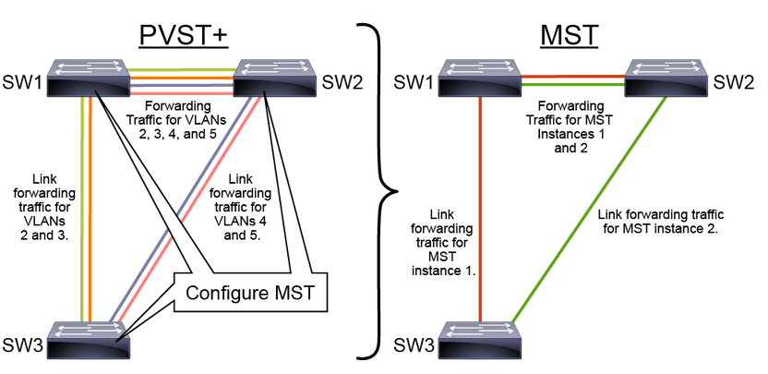

**Task 1: Configuring MST**

MST Regions

MST configuration on each switch:

* Name
* Revision number
* VLAN association table

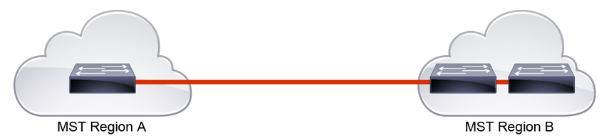

MSTP differs from the other spanning-tree implementations in that it combines some, but not necessarily all, VLANs into logical spanning-tree instances. This difference raises the problem of determining which VLAN is to be associated with which instance. More precisely, this issue means tagging BPDUs so that receiving devices can identify the instances and the VLANs to which they apply.

The issue is irrelevant in the case of the 802.1D standard, in which all instances are mapped to a unique and common instance CST. In the PVST+ implementation, different VLANs carry the BPDUs for their respective instances (one BPDU per VLAN), based on the VLAN tagging information.

To provide this logical assignment of VLANs to spanning trees, each switch that is running MSTP in the network has a single MSTP configuration consisting of three attributes:

* An alphanumeric configuration name (32 bytes)
* A configuration revision number (2 bytes)
* A 4096-element table that associates each of the potential 4096 VLANs supported on the chassis with a given instance

To ensure a consistent VLAN-to-instance mapping, it is necessary for the protocol to be able to identify the boundaries of the regions exactly. For that purpose, the characteristics of the region are included in BPDUs. The exact VLAN-to-instance mapping is not propagated in the BPDU because the switches need to know only whether they are in the same region as a neighbor.

Therefore, only a digest of the VLAN-to-instance-mapping table is sent, along with the revision number and the name. After a switch receives a BPDU, it extracts the digest (a numerical value that is derived from the VLAN-to-instance-mapping table through a mathematical function) and compares it with its own computed digest. If the digests differ, the mapping must be different, so the port on which the BPDU was received is at the boundary of a region.

In generic terms, a port is at the boundary of a region if the designated bridge on its segment is in a different region or if it receives legacy 802.1D BPDUs.

The configuration revision number gives you a method of tracking the changes that are made to an MST region. It does not automatically increase each time that you make changes to the MST configuration. Each time that you make a change, you should increase the revision number by one.

**Activity**

**Step 1:** Using the show spanning-tree summary command, investigate the spanning tree instances on SW3.

On SW3, enter the following command:

SW3# show spanning-tree summary

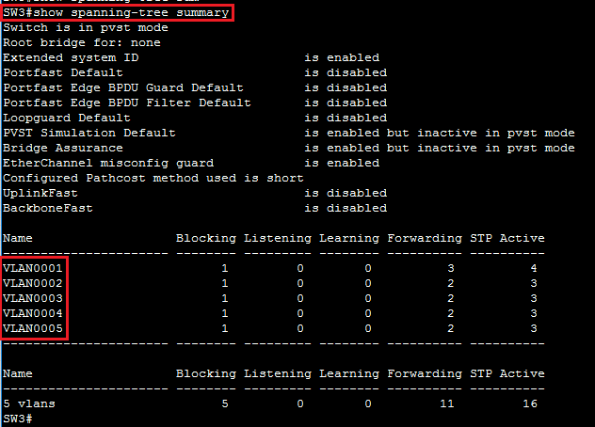

An STP instance is created for each VLAN with PVST+. In this lab, five VLANs translate into five STP instances. If you investigate SW1 and SW2, you will discover that both have the same number of running STP instances as SW3.

On SW1, SW2, and SW3, enter the following commands:

SW1(config)# spanning-tree mst configuration

SW1(config-mst)# name CCNP

SW1(config-mst)# revision 1



SW2(config)# spanning-tree mst configuration

SW2(config-mst)# name CCNP

SW2(config-mst)# revision 1



SW3(config)# spanning-tree mst configuration

SW3(config-mst)# name CCNP

SW3(config-mst)# revision 1



Now all three switches belong to the same MST region.

**Step 3:** On all three switches (SW1, SW2, and SW3), map VLANs 2 and 3 to MST instance 1. Map VLANs 4 and 5 to MST instance 2.

On SW1, SW2, and SW3, enter the following commands:

SW1(config)# spanning-tree mst configuration

SW1(config-mst)# instance 1 vlan 2,3

SW1(config-mst)# instance 2 vlan 4,5

SW1(config-mst)# end



SW2(config)# spanning-tree mst configuration

SW2(config-mst)# instance 1 vlan 2,3

SW2(config-mst)# instance 2 vlan 4,5

SW2(config-mst)# end



SW3(config)# spanning-tree mst configuration

SW3(config-mst)# instance 1 vlan 2,3

SW3(config-mst)# instance 2 vlan 4,5

SW3(config-mst)# end



At this point, MST is configured with three instances. VLANs 2 and 3 belong to instance 1. VLANs 4 and 5 belong to instance 2. All other VLANs between 1 and 4094 that are not in instances 1 or 2 belong to instance 0.

Using the end or exit command will apply the configuration. If you want to abort the change, use the abort keyword.

**Step 4:** Configure SW1 as the primary root bridge for MST instance 1 and the secondary root for instance 2.

On SW1, enter the following commands:

SW1(config)# spanning-tree mst 1 root primary

SW1(config)# spanning-tree mst 2 root secondary



In this example, you have changed the MST switch priority by using spanning-tree mst instance-id root {primary | secondary}. This command is a macro that sets the switch MST priority, which is a number. If you issue show running-config, you will see the switch priority as a number—not as the primary or secondary keyword.

Alternatively, you can change the bridge priority of the switch directly by using the spanning-tree mst instance-id priority priority command.

**Step 5:** Configure SW2 as the secondary root bridge for MST instance 1 and the primary root for instance 2.

On SW2, enter the following commands:

SW2(config)# spanning-tree mst 1 root secondary

SW2(config)# spanning-tree mst 2 root primary



**Step 6:** Change the STP mode to MST on all three switches (SW1, SW2, and SW3).

On SW1, SW2, and SW3, enter the following commands:

SW1(config)# spanning-tree mode mst



SW2(config)# spanning-tree mode mst



SW3(config)# spanning-tree mode mst



Changing the STP mode to MST before doing the actual VLAN-to-instance mappings is not advisable. Every change in the mapping will result in a recalculation of the STP tree.

A switch cannot run MST and PVST+ at the same time. If you issue show spanning-tree command on any of the three switches, you will notice that "MSTP" is now the enabled protocol.

**Step 7:** Again, investigate the spanning tree instances on SW3.

On SW3, enter the following command:

SW3# show spanning-tree summary

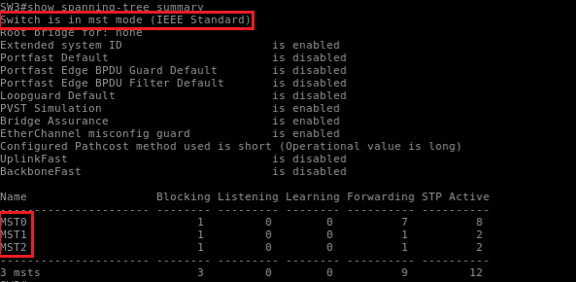

MST runs three instances: the default MST instance 0 and the two you configured—MST instance 1 and MST instance 2.

**Step 8:** Using the spanning-tree mst configuration command, investigate the MST configuration on SW3.

On SW3, enter the following commands:

SW3(config)# spanning-tree mst configuration

SW3(config-mst)# show current

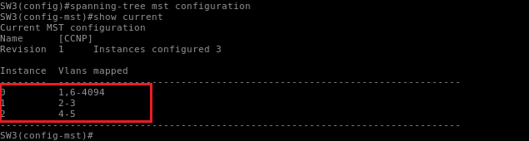

VLANs 2 and 3 are mapped to MST instance 1. VLANs 4 and 5 are mapped to MST instance 2. All other VLANs are mapped to MST instance 0, or the IST.

To verify the currently applied MST configuration, use show current in MST configuration mode. To verify the pending MST configuration, use show pending in MST configuration mode. When you type exit or end, the pending configuration will become current. Thus, show current and show pending will produce the same outputs.

**Step 9:** Verify the MST message digest on all three switches.

On SW1, SW2, and SW3, enter the following commands:

SW1# show spanning-tree mst configuration digest

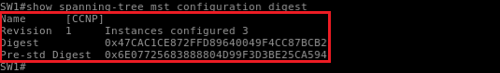

SW2# show spanning-tree mst configuration digest

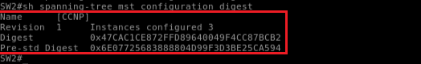

SW3# show spanning-tree mst configuration digest

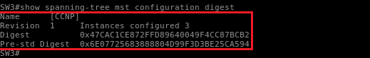

Since MST configuration is identical on all three switches in a region, the digest matches. A mismatch in the digest would indicate that the VLAN lists do not match between switches. Note that the digest may be different in your case. It only matters that the digest is the same on all three switches.

The "Pre-std Digest" refers to the Cisco legacy prestandard implementation of MST. Cisco developed a proprietary version of MST called MISTP, which had similar principles as MST.

**Step 10:** On SW3, verify MST instance 1 and MST instance 2 mappings and Layer 2 convergence.

On SW3, enter the following commands:

SW3# show spanning-tree mst 1

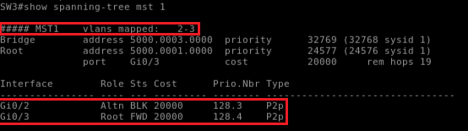

SW3# show spanning-tree mst 2

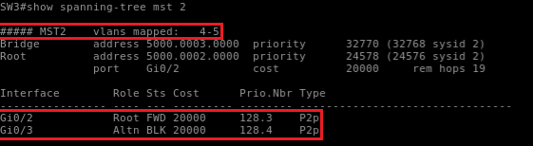

MST instances 1 and 2 have two distinct Layer 2 topologies. Instance 1 uses the uplink toward SW1 as the active link and blocks the uplink toward SW2. Instance 2 uses the uplink toward SW2 as the active link and blocks the uplink toward SW1.

You can use show spanning-tree mst 1 to verify that SW1 is the root bridge for MST instance 1. Also, you can use show spanning-tree mst 2 on SW2 to verify that SW2 is the root bridge for MST instance 2.

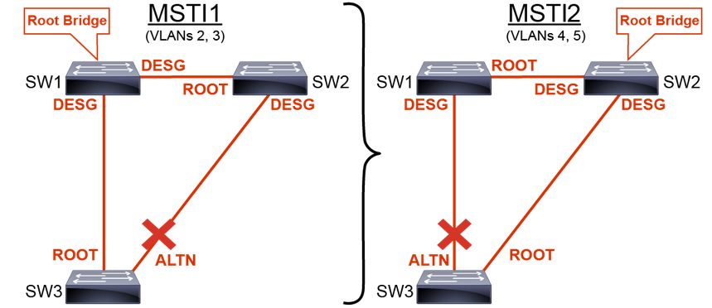

**Task 2: Configuring MST Port Priority**

**MST Port Priority**

The port priority functions the same as with other STPs, except with MST, port priorities are configured per instance.

Like any other STP, if a loop occurs, MST can use the Port_ID of the sender to select the forwarding interface.

To set the MST port priority for a given MST instance:

Switch(config)# interface GigabitEthernet0/2

Switch(config-if)# spanning-tree mst 1 port-priority 64

To verify the Port_ID settings that are sent:

Switch # show spanning-tree mst 1

MST, like any other STP, uses this sequence of four criteria to choose the best path:

* Lowest BID (Bridge ID)
* Lowest root path cost
* Lowest sender BID
* Lowest sender Port_ID

You can assign higher sender priority values (lower numerical values) to interfaces that you want selected first, and lower sender priority values (higher numerical values) that you want selected last. If all sender interfaces have the same priority value, MST puts the interface with the lowest sender Port_ID in the forwarding state and blocks the other interfaces.

To change the STP port priority of an interface, enter interface configuration mode and use the spanning-tree mst instance port-priority priority command.

For the instance variable, you can specify a single instance, a range of instances that are separated by a hyphen, or a series of instances that are separated by a comma. The range is 0 to 4094. For the priority variable, the range is 0 to 240 in increments of 16. The default is 128. The lower the number, the higher the priority. To return the interface to its default setting, use the no spanning-tree mst instance port-priority interface configuration command.

To verify port priority settings, use show spanning-tree mst interface interface or show spanning-tree mst instance. However, information is displayed only for ports that are in a link-up operative state. Otherwise, you can use the show running-config command to confirm the configuration.

Activity

**Step 1:** On SW3, set the MST port priority for MST instance 1 to 64 on interface GigabitEthernet0/2.

On SW3, enter the following commands:

SW3(config)# interface GigabitEthernet0/2

SW3(config-if)# spanning-tree mst 1 port-priority 64



**Step 2:** On SW3, verify port priority for all interfaces in MST 1.

On SW3, enter the following commands:

SW3# show spanning-tree mst 1

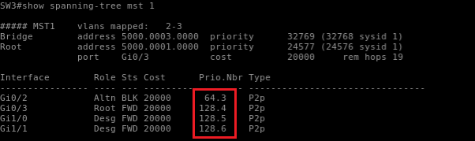

MST instance 1 now shows that interface GigabitEthernet0/2 has a priority of 64, and the remaining interfaces are still at the default priority of 128.

**Task 3: Configuring MST Path Cost**

**MST Path Cost**

The path cost functions the same as with other STPs, but with MST, port costs are configured per-instance.

Like with any other STP, the MST path cost default value is derived from the media speed of an interface. If a loop occurs, MST uses the cost to select the forwarding interface.

Switch(config)# interface GigabitEthernet0/2

Switch(config-if)# spanning-tree mst 1 cost 10000

Sets the MST cost of the interface to 10000

SW3# show spanning-tree mst

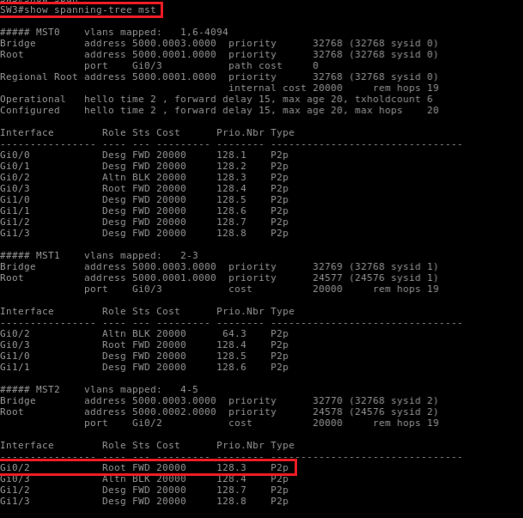

Verifies MST path cost configuration

MST, like any other STP, uses a sequence of four criteria to choose the best path:

* Lowest BID
* Lowest root path cost
* Lowest sender BID
* Lowest sender Port_ID

You can assign lower-cost values to interfaces that you want selected first and higher-cost values that you want selected last. If all interfaces have the same cost value, MST puts the interface with the lowest sender Port_ID in the forwarding state and blocks the other interfaces.

To change the STP cost of an interface, enter interface configuration mode for that interface and use the command spanning-tree mst instance cost cost. For the instance variable, you can specify a single instance, a range of instances that are separated by a hyphen, or a series of instances that are separated by a comma. The range is 0 to 4094. For the cost variable, the range is 1 to 200000000; the default value is usually derived from the media speed of the interface.

To verify MST path cost settings, use show spanning-tree mst interface interface-id or show spanning-tree mst instance-id. However, information is displayed only for ports that are in a link-up operative state. Otherwise, you can use the show running-config command to confirm the configuration.

**Activity**

**Step 1:** On SW3, set the MST path cost for MST instance 1 to 10,000 on interface GigabitEthernet0/2.

On SW3, enter the following commands:

SW3(config)# interface GigabitEthernet0/2

SW3(config-if)# spanning-tree mst 1 cost 10000



**Step 2:** On SW3, verify the path cost for all interfaces in MST 1.

On SW3, enter the following commands:

SW3# show spanning-tree mst 1

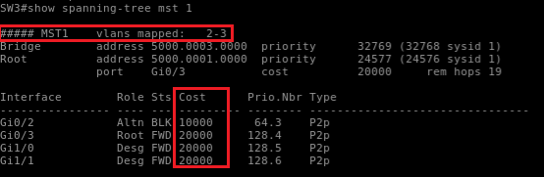

MST instance 1 now shows that the path cost for interface GigabitEthernet0/2 has been changed to 1,000,000. All other interfaces show the default path cost of 2,000,000.